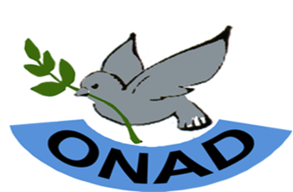
PRESS RELEASE from ONAD
New country = new name for a leading nonviolence organization
14th of November 2011
SONAD (Sudanese Organization for Nonviolence and Development) has on November 9th 2011 officially changed its name to ONAD - Organization for Nonviolence and Development, by simply dropping “Sudanese” as it refers to the political Sudan (North Sudan). The new name is approved by the Ministry of Justice, Republic of South Sudan.
The decision to change the name was taken by the members of the organisaion, as a reference to Sudan no longer fit with a national organisation operating in South Sudan especially after independence of our country.
ONAD South Sudan is now the legal name for the former SONAD in Southern Sudan. The organisation however maintains its vision of working for “a nonviolent, peaceful and democratic society”.
“We will continue to promote nonviolence, reconciliation and peace not only in South Sudan but in Africa as a whole as the organization aspires to become a leading nonviolence organization on the continent”, said Moses Monday John, the Executive Director of ONAD. “The Nonviolence and Training of Trainers, which will end today, is a practical step where participants represented three nationalities/countries namely; South Sudan, Sudan and Uganda”, he added.
ONAD wishes to take this opportunity to encourage the political leadership in both Republics of Sudan and South Sudan to stick to continuous political dialogue to address post CPA issues, especially the growing crisis in South Kordofan and Blue Nile States and resolve the issue of Abyei.
Since 2004 SONAD has been working as a national peace organization with offices in Khartoum and Juba and has contributed in building peace through its nonviolence techniques. This resulted into its nomination (twice) for the Aachen (international) peace prize, Germany, and acceptance of membership in local, regional and international networks such as Sudanese Network for Democratic Elections (SuNDE) Juba, Coalition of Peace in Africa Nairobi Kenya, the International Fellowship of Reconciliation (IFOR) – Alkaamar, the Netherlands, War Resisters International – London, UK, and many other networks.
ONAD was initiated in 1994 by Southern Students activists at University of Juba in Khartoum and over the years has attracted large and diversified members in terms of ethnicity, religion and gender from all over Sudan. The organization was first registered in 2004 with the Federal Ministry of Humanitarian Affairs as Sudanese Organization for Nonviolence and Development (SONAD) and then in 2006 with the Ministry of Legal Affairs and Constitutional Development, Government of Southern Sudan in Juba.
For more information, contact: Moses Monday John, Executive Director at the following addresses:

